EECS 1011

LAB D REPORT

SECTION 10

KIET LE

ID: 218052787

**INTRODUCTION:** In this lab I sketched three 3D drawing with isometric paper. Then I used MATLAB in order to create the Section 10, Sketch 2 (Figure 10/2) 3D drawing. **LAB OBJECTIVES:** The objective of this lab was to sketch 3 figures assigned to me and recreate one of them in MATLAB using the “patch” function. **SOLUTION:** I successfully sketched the drawings on isometric paper in MATLAB. I used a series of patch functions in order to carefully build Figure (10/2) in MATLAB with unique colors (green, red, cyan, yellow, black) representing each side. Also halfway through coding the figure, I discovered how to create the sides without needing to create separate rectangles. Which is why there is a mix of whole and separate sides. **RESULTS:** The hand drawn and MATLAB sketches were successful. **CONCLUSION:** The isometric paper and MATLAB are good ways to sketch 3D block sketches.

PRELAB AND 3 SKETCHES (SECTION 10)

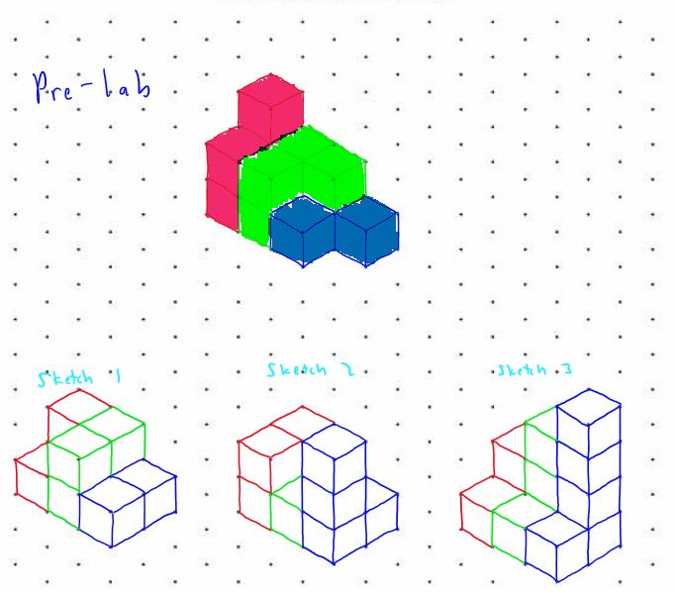

MATLAB CODE (SECTION 10 FIGURE 2)

%bottom

patch([0,3,3,0,],[0,0,2,2,],[0,0,0,0,],'white', 'FaceAlpha', 0.5)

%wall red

patch([0,1,1,0],[0,0,0,0],[0,0,2,2],'red', 'FaceAlpha', 0.5)

patch([1,3,3,1],[0,0,0,0],[0,0,1,1],'red', 'FaceAlpha', 0.5)

patch([2,3,3,2],[0,0,0,0],[1,1,3,3],'red', 'FaceAlpha', 0.5)

patch([1,2,2,1],[1,1,1,1],[1,1,2,2],'red', 'FaceAlpha', 0.5)

%wall green

patch([3,3,3,3],[0,2,2,0],[0,0,1,1],'green', 'FaceAlpha', 0.5)

patch([3,3,3,3],[0,1,1,0],[1,1,3,3],'green', 'FaceAlpha', 0.5)

patch([2,2,2,2],[1,2,2,1],[1,1,2,2],'green', 'FaceAlpha', 0.5)

patch([1,1,1,1],[0,1,1,0],[1,1,2,2],'green', 'FaceAlpha', 0.5)

%wall black

patch([0,0,0,0],[0,2,2,0],[0,0,2,2],'black', 'FaceAlpha', 0.5)

patch([2,2,2,2],[0,1,1,0],[1,1,3,3],'black', 'FaceAlpha', 0.5)

%wall yellow

patch([0,2,2,0],[2,2,2,2],[0,0,2,2],'yellow', 'FaceAlpha', 0.5)

patch([2,3,3,2],[2,2,2,2],[0,0,1,1],'yellow', 'FaceAlpha', 0.5)

patch([2,3,3,2],[1,1,1,1],[1,1,3,3],'yellow', 'FaceAlpha', 0.5)

%wall cyan

patch([0,1,1,2,2,0],[0,0,1,1,2,2],[2,2,2,2,2,2],'cyan','FaceAlpha', 0.5)

patch([2,3,3,2],[0,0,1,1],[3,3,3,3],'cyan','FaceAlpha', 0.5)

patch([1,2,2,1],[0,0,1,1],[1,1,1,1],'cyan','FaceAlpha', 0.5)

patch([2,3,3,2],[1,1,2,2],[1,1,1,1],'cyan','FaceAlpha', 0.5)

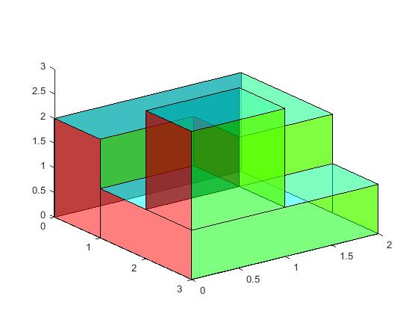MATLAB FIGURE (Figure 10/2)

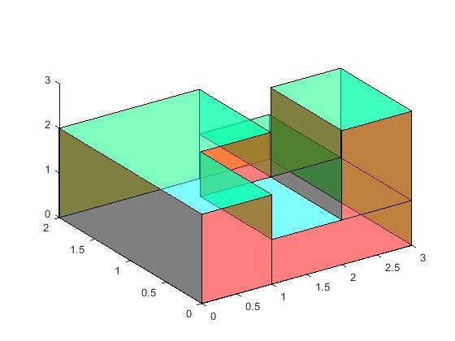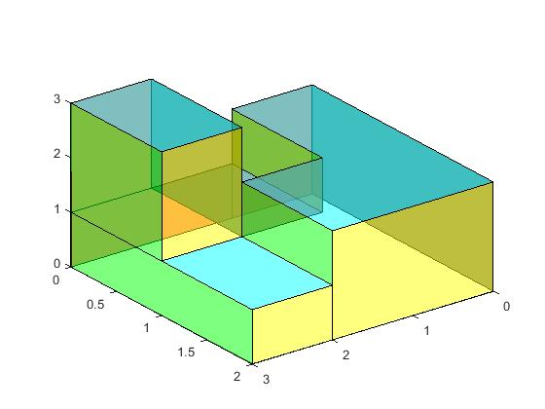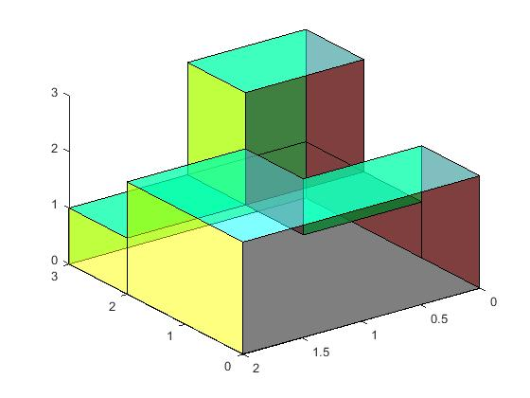

**BACK VIEW**

**FRONT VIEW**